LAB SESSION: 05
(Stack Implementation Using Linked List)

Class For Node: Class For Stack:
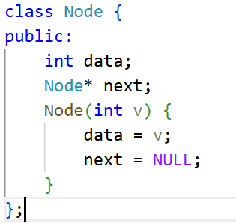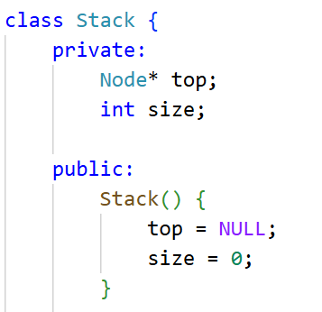

- Modify the program to allow user input for all stack operations.
CODE:
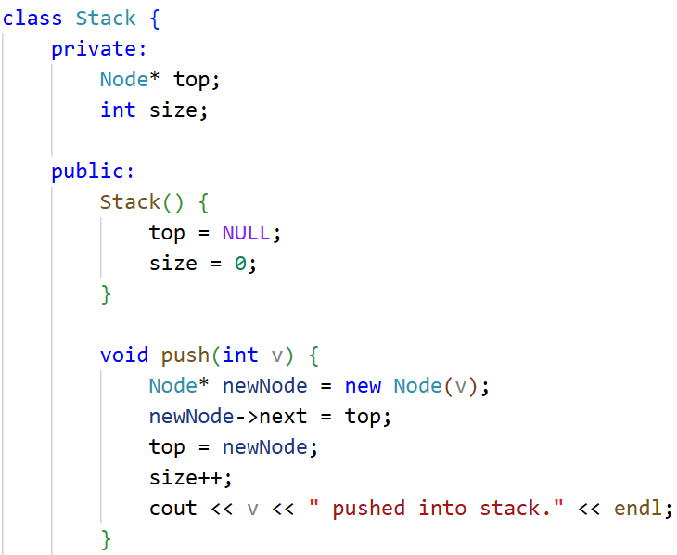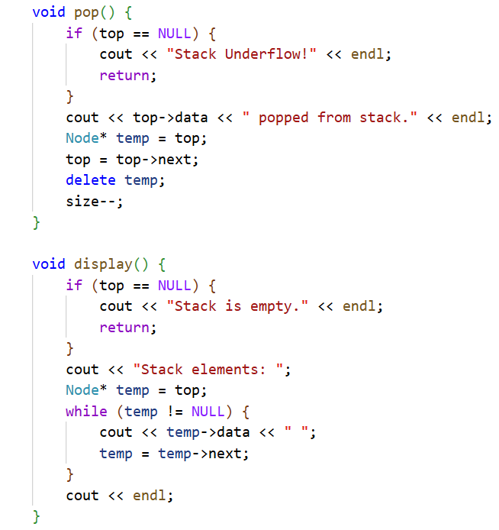
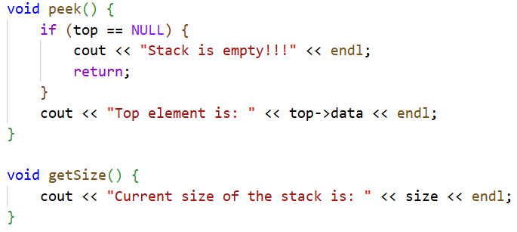

int main() {
Stack s;
int choice, value;

do {

cout << "\n*******************************" << endl;
cout << " LINKED LIST STACK MENU" << endl;
cout << "*********************************" << endl;
cout << "1. Insert element (Push)" << endl;
cout << "2. Delete top element (Pop)" << endl;
cout << "3. View top element (Peek)" << endl;
cout << "4. Show all elements (Display)" << endl;
cout << "5. Get Size" << endl;
cout << "6. Exit" << endl;
cout << "-------------------------------" << endl;
cout << "Enter your choice: ";
cin >> choice;

switch (choice) {
case 1:
cout << "Enter value to push: ";
if (cin >> value) {
s.push(value);
} else {
cout << "Invalid value entered." << endl;
}
break;

case 2:
s.pop();
break;
case 3:
s.peek();
break;
case 4:
s.display();
break;
case 5:
s.getSize();
break;
case 6:
cout << "Exiting program. Goodbye!" << endl;
break;
default:
cout << "Invalid choice. Please try again." << endl;
}
} while (choice != 6);
}

Output:
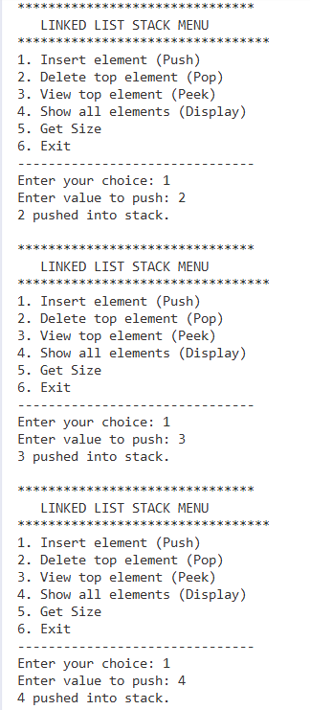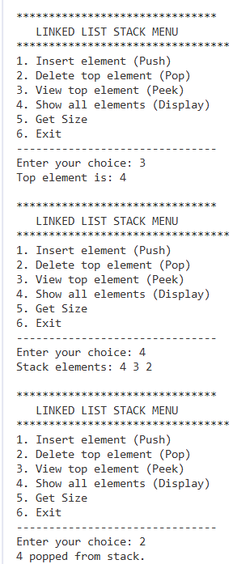

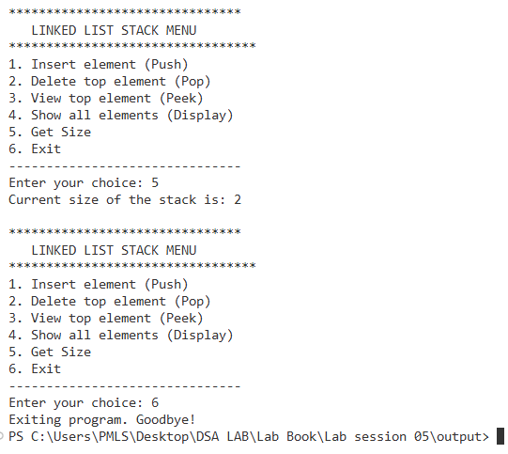
- Implement a peek() function for linked list stack.
CODE:
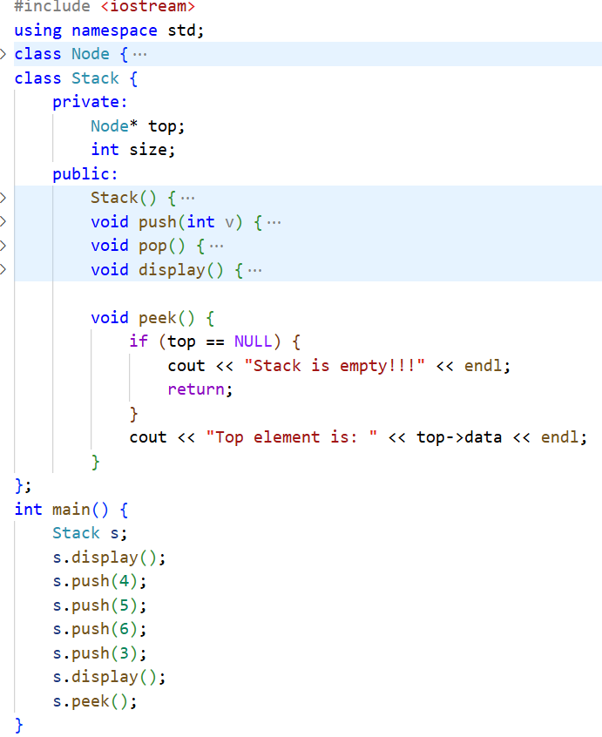}

OUTPUT:
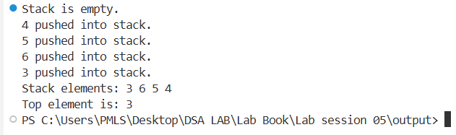
- Check if the stack is empty before performing pop or display.
CODE:
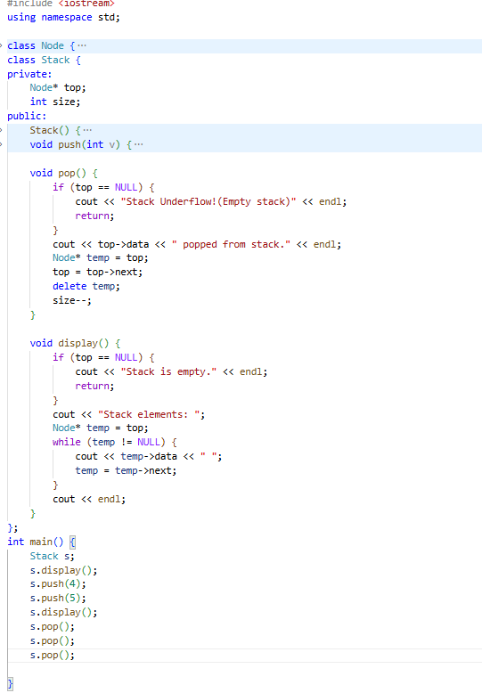

OUTPUT:
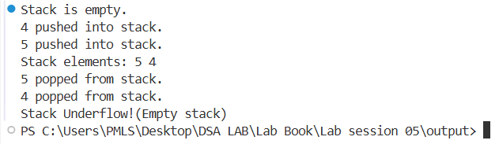
- Reverse a linked list stack using another stack.
CODE:
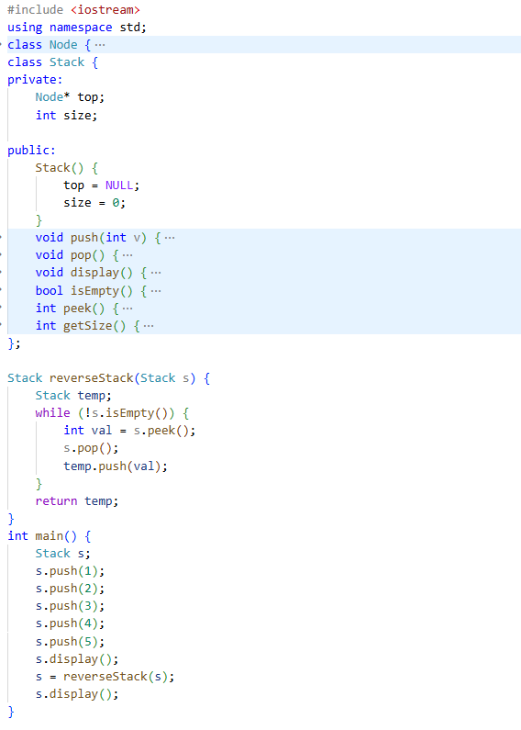
OUTPUT
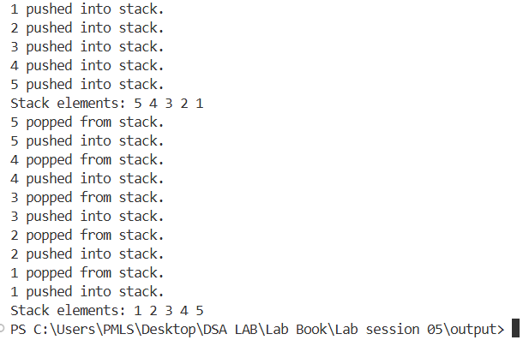
- Implement balanced parentheses checking using a linked list stack.
CODE:

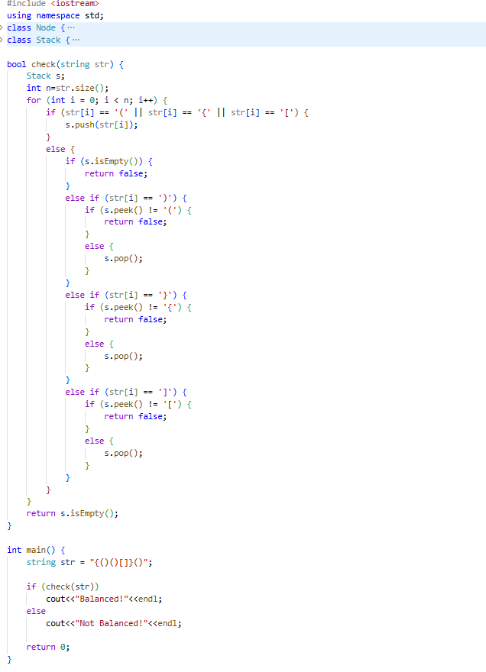

OUTPUT

